LMS Data 6U 500mm Deep Data Cabinet, Wall Mounted, 19" Rackmount (550x500x380mm), Multi-functional Wall Enclosures Cabinet, Mount Rack, IT Data Network Equipment with Cable Management & Lock.

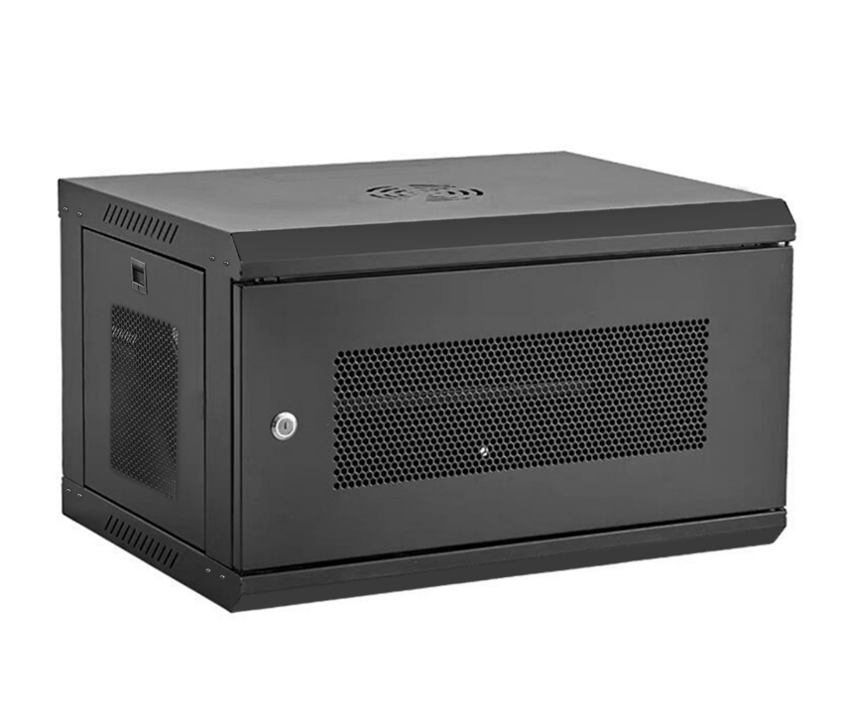

**DESCRIPTION**

* ✔️ COMPLETE STRUCTURE ↪ Introducing the new C-series range of 500MM deep wall enclosures, ETSI 19” front/rear proﬁles, 550X500X380mm (WxDxH)
* ✔️ MAXIMUM SAFETY ↪ Attractive design lockable safety door. Also reversible if required. Opening the door 180 degrees.
* ✔️ CONVENIENCE & SPACE-SAVING DESIGN ↪ LMS Data 6U cabinet is a Pre built wall cabinet, Wall mountable with removable side panels and cable tunnels for maximum space usage
* ✔️ QUALITY MADE FOR YOU ↪ Robust powder-coated, Gray detailing and quality alloy assembly means its IDEAL for a whole host of DATA VoIP and CCTV installations
* ✔️ SIMPLICITY, EASY-TO-INSTALL ↪ wall deployment & Pre-built. Easy-mount wall attachment bar. Supplied with fixed shelf and bag of M6 fixings

**Product information**

Size Name:**6U - 550x500x380mm**

Technical Details

|  |  |
| --- | --- |
| Brand | ‎Lms Data |
| Manufacturer reference | ‎CAB-C6-SM-FBM |
| Manufacturer | ‎Dynamode |

Additional Information

|  |  |
| --- | --- |
| ASIN | B09DKM7F7Z |
| Date First Available | 24 Aug. 2021 |